Intelligent Disclosure - Training

Intelligent Disclosure – Overview

Intelligent Disclosure – Solution

What It is
By using this solution, you can:
- Improve productivity throughout automation and collaboration
- Empower the office of CFO, together with whoever needs to combine narratives and numbers
- Lead the change and adapt to regulatory changes
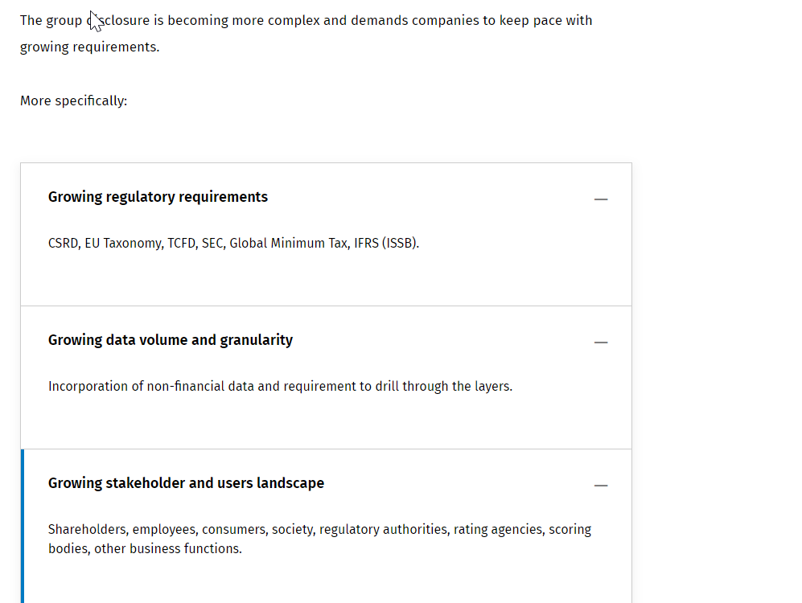
- The last step in the document creation and production process, commonly called the 'last mile', is typically manually handled, time-consuming, and prone to errors.
- In fact, in this phase, often process managers have to:
  - Combine information from different sources (ERP, consolidation system, etc.)
  - Collect additional information missing from the feeding systems (market share, competitor performance, etc.)
  - Collaborate with various departments within the organization (sales, marketing, production, etc.) for comment collection
  - Produce information based on predefined technological standards, such as iXBRL

Financial close :
- Process starts with Data extraction from accounting system and ends with the delivery of consolidated reports
- Disclosure Management : Building upon the generated consolidation reporting book generated, this process culminates in the creation of a final document that is ready for publication.

- Data and financial integrity
- Up-leveled narratives
- No learning curve with Microsoft 365
- Copilot automated narrative
It allows you to manage document creation, to collect and automatically update data from different sources, and to manage the full workflow from document creation to final publication.
To leverage the Intelligent Disclosure solution there are some mandatory technical requirements each user has to satisfy:
- You must have a Microsoft Office 365 account
- The Microsoft Office 365 account must include SharePoint Online
Further, the Intelligent Disclosure solution is only available on the Tagetik Cloud and from CCH Tagetik Service Pack 28.

For the user rights :
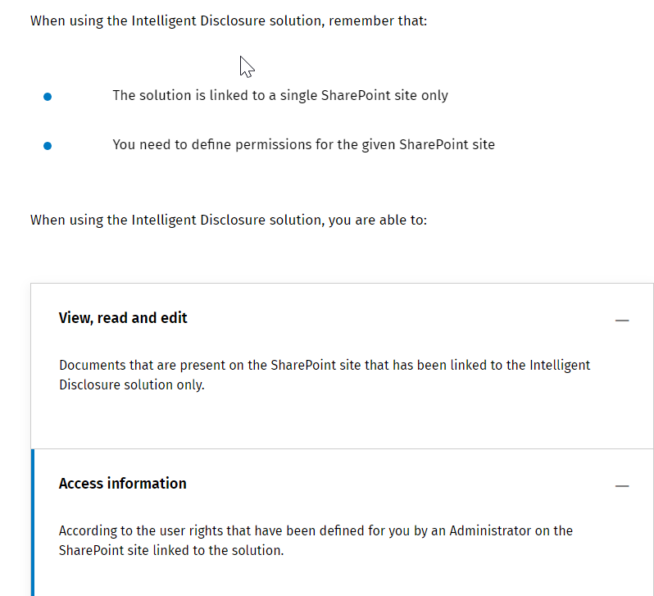

2 types of user roles :
- Admi user :
  - Create an outline
  - Create a document
  - Set up user rights
- Contributor Users
  - Create a document objects
  - Collect content
  - Validte and approve content
  - Export and publish documents
  - Maintain the document and generate new document versions

Intelligent Disclosure - Open an existing document

How to access a document
From Word Add – in

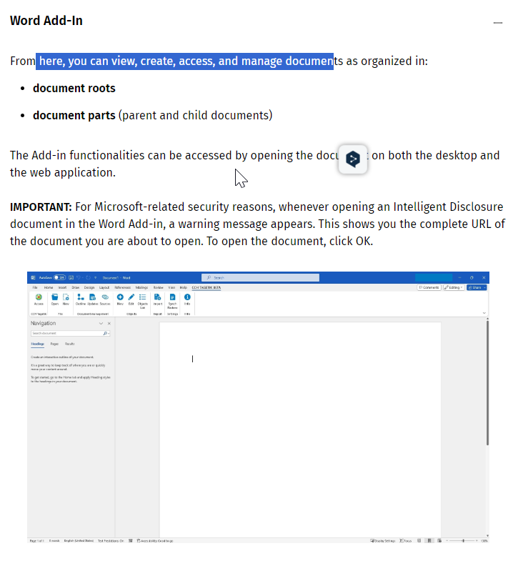
From Sharepoint Interface
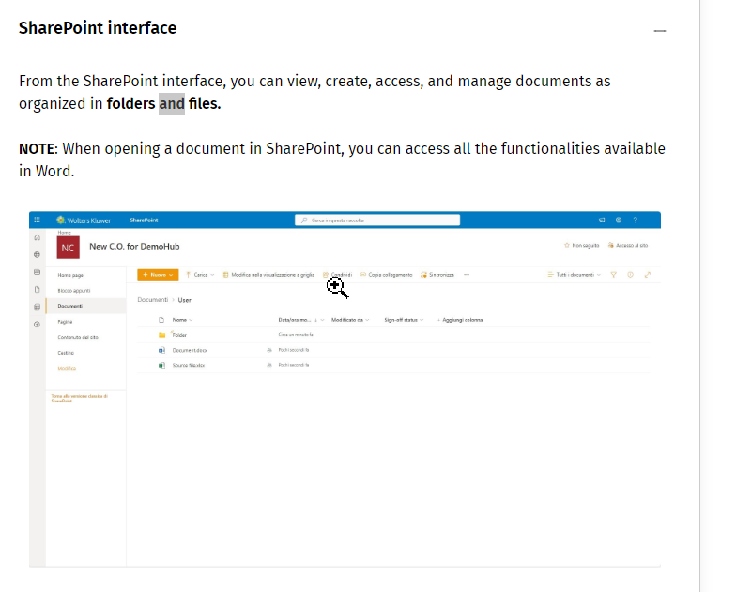

Add-in Action Menu
See the Scribe

Display Structure and content
In Bold : What you have access to
In grey : Document you don’t have access to but still can see them, but not edit.

View Document properties
General :
- Document name
- Additional info (If any)
- Document Language
Parameters
Whether data in the document is retrieved from one or more TGK databases.

IMPORTANT: Within each DB, you must specify the dimensions to be used to filter your data. By default, dimensions set in the properties of a parent document will be inherited by its child documents. This setting can be disabled or integrated with additional dimensions which you want to filter your data by.

Advanced :
Format options for numbers and images

Intelligent Disclosure - Create a document
A document is a template where you can define the basic information you need to create the word document, called Document root.
This is used by contributor to Collect financial information and collect non financial information
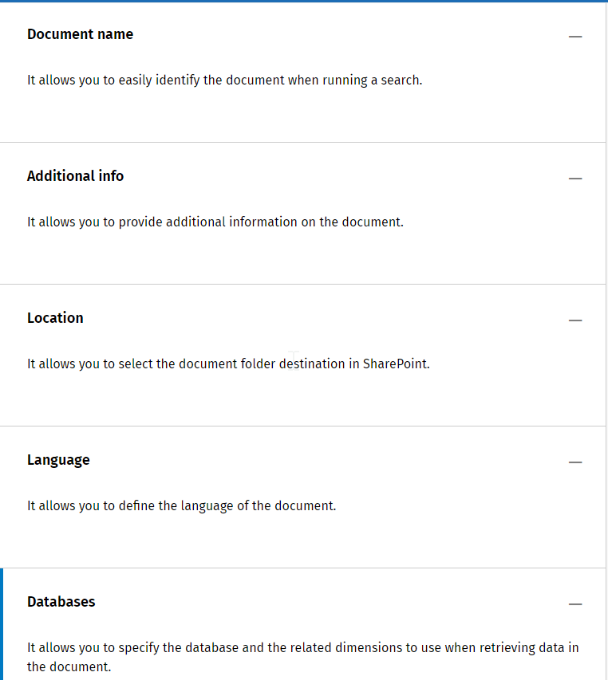
Format Option : Specify the format of number date, image, …

A document part can be :
- A parent document when it is made of one or more lower level documents
- A child document when it is part of an upper level document
The content of the document part will be displayed in the document root and will this be published at the end of the disclosure process
- There can be as many doc part as you require
- Multiple users can work on the same document part at the same time
- A single document part can be linked to multiple outliens
Split a document into document parts
When to split :
In some cases, splitting a document into document parts can prove useful from a project management perspective.
It allows you to:
- Limit a single user or a team visibility on specific document parts
- Manage a single document submission and rejection process that might have been assigned to different users
Smth don’t need to do that
- There is no need to define different user for the document
- There is no need to define team visibility on the document

Create a document part :
- This can be created from scratch or from existing part
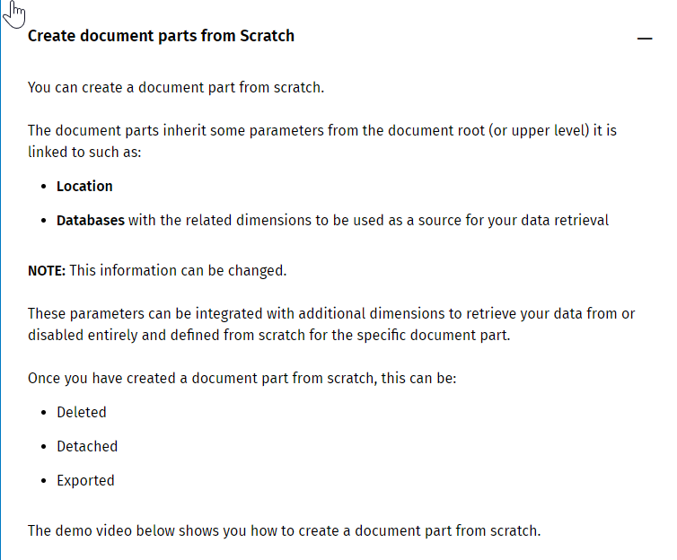
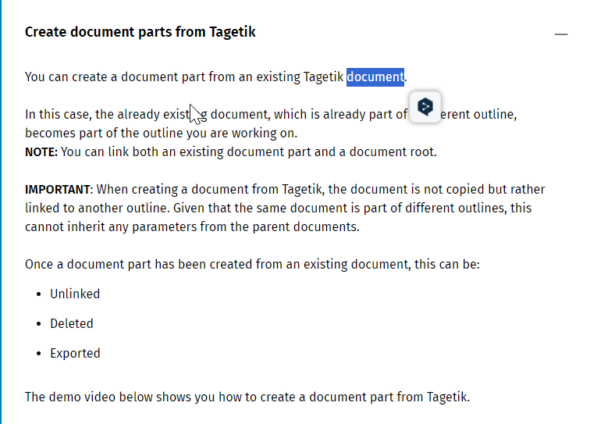

Intelligent Disclosure - Create a document outline
Flat or multi level structure
Flat Structure:
- This structure allows you to split document into multiple parts that are all on the same level.
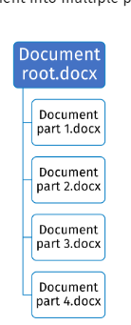
Multilevel Structure :
- This structure allows you to split the document into first level document parts (parent documents) that are further split into one or more sub-levels (child documents).

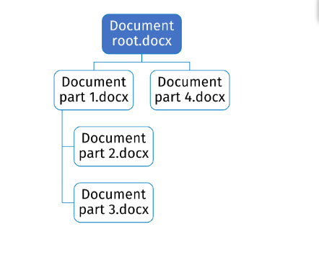

Manage structure
- In the document library, from word desktop application, possible to manage the structure of the document root and its parts by clicking the dedicated button manage structure
- Branch out document structure If needed

To change the structure : need to close the document.
Makesure that : All document parts are consistent in terms of format
To reject a subpart, need to reject the above parts also
When submitting an ID document : have to first submit the lower level
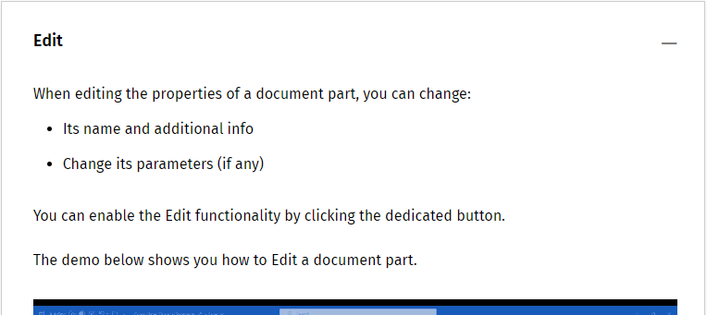
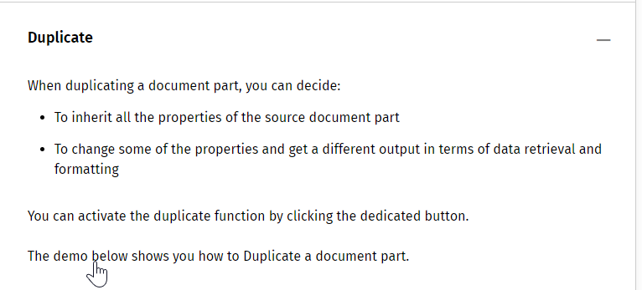

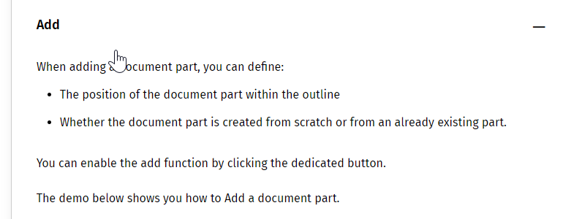
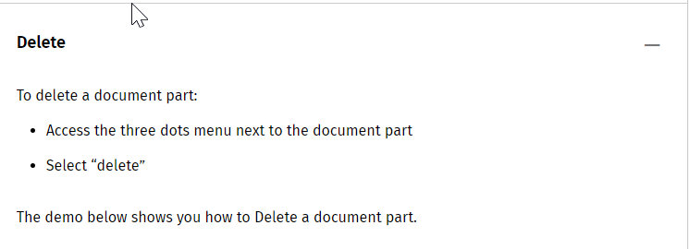

Intelligent Disclosure - Create and edit objects

When creating an Intelligent Disclosure document, you can refer to information coming from external sources, such as a Tagetik database or an external Excel file.

This information is referenced via objects.

Can insert various type of object in a document :
- Tagetik object :
  - Table
  - Chart
  - Amount
  - Dimension Attribute
- Excel objects
  - Table
  - Chart
  - Amount
- Free objects :
  - Check Box
  - Drop Down
  - Free Text
When creating an object in a document : Always specify the object name and type
Table from Tagetik
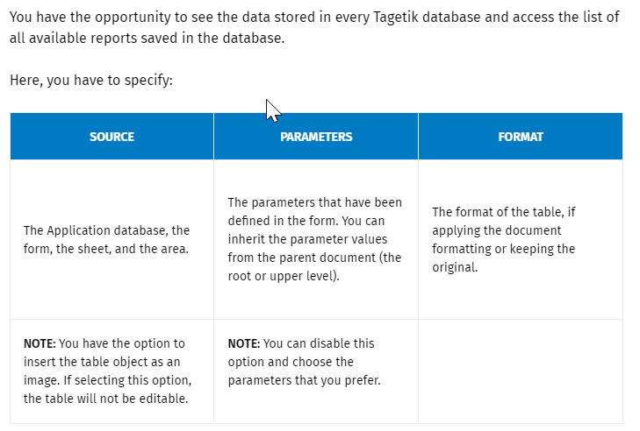
Table from excel
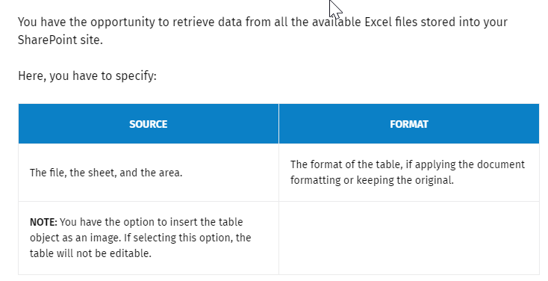
When adding a table object, need to map the zone
We can also add an amount object to insert a numeric value retrieved from an external source .
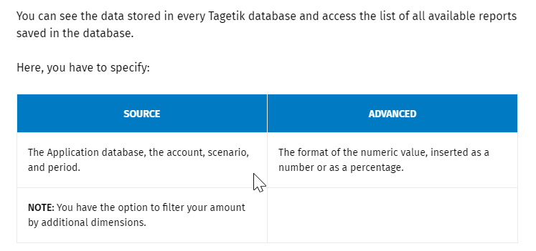
Those amount can be filtred by different dimensions
When selecting Excel as a source
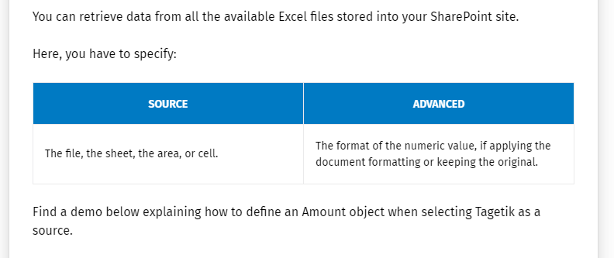
The amount can be added from a specific cell or from a specific range.

Also possible to retrieve Chart from the document : As an image or as a chart directly from the source file.

It is also possible to retrieve Tagetik dimensions cod or description or rates, ..from the Tagetik database

The Free Text can be added in the document. Those have to be designed as an object
Idem for the Check boxes.
The Drop-down object let you to:
- Insert a drop-down list wherever you prefer in the document
- Have this widget available directly among the object options, without having to enable a special Word menu to access it
- Leverage all Add-in functionalities
The different drop down list can be manually added directly.

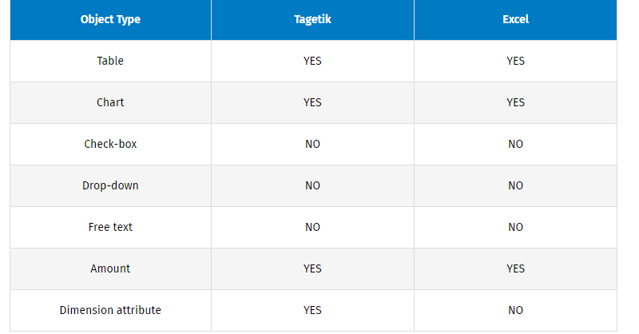

It is possible to display reports available and dimensions defined in different Tagetik databases you have access to .

Once you have created your object, you can :
Insert, change and add.

Intelligent Disclosure - Update documents and objects

Once the document has been created, you can change it by adding, deleting or editing content. To make changes within a child document viable in a parent document, this must be updated.
To update : you can :
- Get changes: It helps you to see the changes made to the child document displayed in the parent document that you have currently open.
- Updates and get changes: It manages to update the data in the objects inserted into the child document and see the changes displayed in the parent document that you have currently open.
See video
When updating object data from a parent document, data is updated in all its chald and sub-child documents(if existing) with no limit on the number of existing sub levels.
Rember:
Disable the Include data option to display the updated content in the parent document

• Enable the Include data option to update the object data and display the updated content in the parent document
To make and display an update on one or more child documents, the parent document must be open.
With the object list items:
- You can see the list of created objects, the available updates and changes made to objects
- You can display an update on a list of ibject or only one or on all.

Only one object at a time
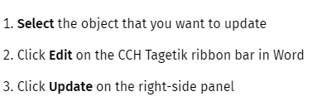
Objects grouped by document :
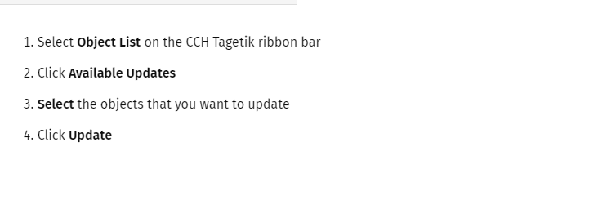

It is also possible to track the change :
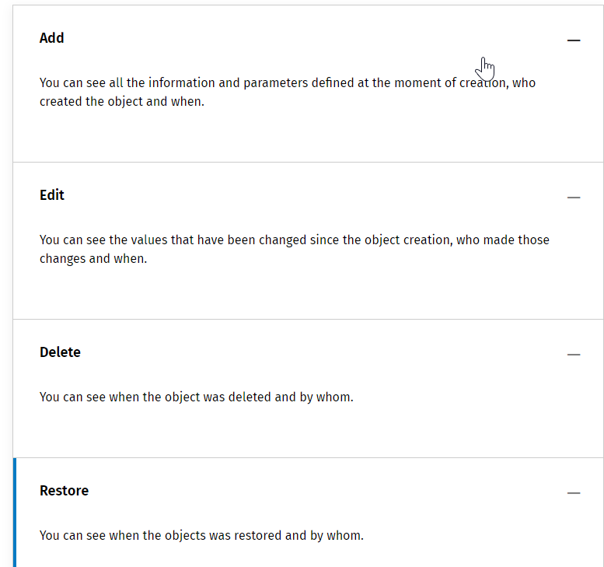
You will be able to see who did the change, …

Intelligent Disclosure - Manage and maintain documents

As it is possible to do on Word, you can track the different changes made in the document.
You can :
- Track : Changes to an item or file, including who made the changes and when. In this way, you can check the work in progress of single contributors.
- View : A list of version of a file.
- Restore: A previous version of a document created using Word, Excel, or PowerPoint.
- Compare :Different versions to understand the progress of the document.

You can export a document :
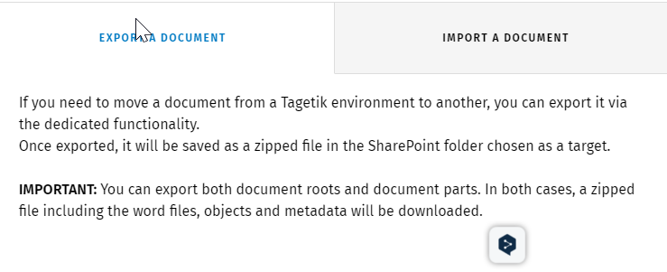
Or Import a document
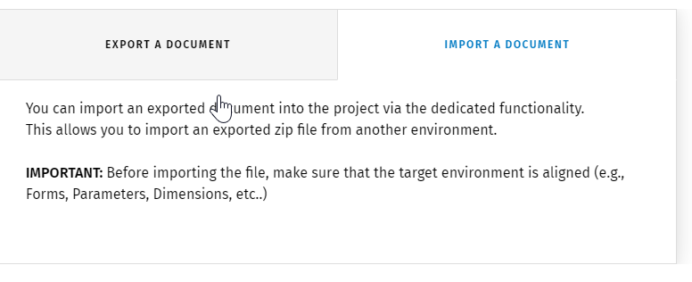
When importing a TGK document, use DB Mapping, a mapping tool for matching the DB name. Otherwise, you will have to manually change the source of every single object.
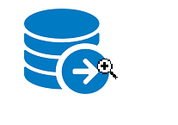
It is also possible to roll forward a document without having to create a new one from scratch
- Duplicate : You can duplicate the document using the dedicated button
- Change : change the document scenario parameters
- Update : Update the document and all the existing objects.

Intelligent Disclosure - Takeaways

Intelligent Disclosure - Time to practice!

